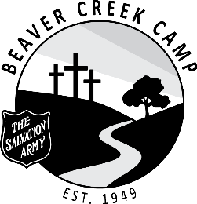

POSITION: Maintenance Staff – 2022 Summer Ministry Team

DURATION: July 11 – August 19, 2022 (6 Weeks)

OBJECTIVE: To ensure the maintenance and cleanliness of all camp property

SUPERVISION: Maintenance Manager / Head Chore / DYS’

RESPONSIBILITIES:

- Regularly cut grass and trees when necessary
- Sweep walkways
- Cut and store firewood
- Paint and provide minor repairs to buildings and equipment
- Regular pick up and incineration of trash
- Clean toilets
- Restock supplies
- Participate in camp clean up at the end of each camp
- Attend all staff devotions (unless excused by the DYS’)
- Ensure living accommodations is kept clean and tidy
- Be flexible and have a good disposition
- Work within the total camp program and cooperate with other staff members
- Be loyal to the aims, policies and regulations of the camp
- Maintain a responsible level of maturity and leadership
- Be familiar with Summer Staff Handbook, and all procedures and resources
- Perform any task beyond those assigned as required.
- All Staff are required to be in their private quarters by 11:00 pm each night

DECLARATION: As a staff member of TSA Beaver Creek Camp, I will work toward a Christ-centered camp. I will conduct myself in an honourable manner at all times, according to Christian principles and the Standards of The Salvation Army.
Staff Member |  | Date Signed
Witness |  | Date Signed
Divisional Youth Secretary |  | Date Signed

