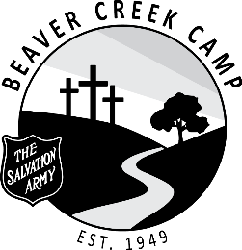

POSITION: Kitchen Staff (3)

DURATION: July 2 – August 26, 2022 (8 Weeks + 2 Days)

OBJECTIVE: Assist in the efficient running of the camp kitchen and dining room

SUPERVISION: Head Cook / Hospitality Coordinator / DYS’

RESPONSIBILITIES:

- Assist the cook in food preparation
- Set up tables and chairs neatly
- Serve meals and snacks efficiently and courteously
- Waste removal
- Operate dishwasher
- Wash dishes and pots when necessary
- Wash tables, chairs and floors as assigned
- Sweep kitchen, panty and serving areas as assigned
- Attend all staff devotions (unless excused by the DYS’)
- Ensure living accommodations is kept clean and tidy
- Be flexible and have a good disposition
- Encourage spiritual growth
- Work within the total camp program and cooperate with other staff members
- Be loyal to the aims, policies and regulations of the camp
- Maintain a responsible level of maturity and leadership
- Be familiar with Summer Staff Handbook, and all procedures and resources
- Perform any task beyond those assigned as required.
- All Staff are required to be in their private quarters by 11:00 pm each night

DECLARATION: As a staff member of TSA Beaver Creek Camp, I will work toward a Christ-centered camp. I will conduct myself in an honourable manner at all times, according to Christian principles and the Standards of The Salvation Army.
Staff Member |  | Date Signed
Witness |  | Date Signed
Divisional Youth Secretary |  | Date Signed

