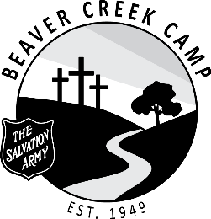

POSITION: Head Cook

DURATION: June 27 – August 26, 2022 (9 Weeks)

OBJECTIVE: The preparation of meals for campers and staff, as well as operation of the kitchen.

SUPERVISION: Hospitality Coordinator / DYS’

RESPONSIBILITIES:
- Work with the menu as established by Camp Board Program Committee.
- Responsible for the timely preparation of all meals.
- Responsible for general functioning of the kitchen and staff.
- Ensure compliance with the Canada Food Guide and all other applicable health regulations.
- Responsible for receiving, checking and storing food orders.
- Encourage, mentor and supervise the work of support staff in the kitchen.
- Develop and implement staff training and work schedules in conjunction with the Hospitality Coordinator.
- Assist in the constant cleanliness and sanitation of: freezers, walk-in fridge, stoves and food preparation surfaces.
- Maintain an inventory of supplies and food.
- At the end of the summer camping season, assist the Hospitality Coordinator in making an inventory of supplies and food. Prepare all food supplies for storage.
- Participate in camp cleanup at the end of each camp with emphasis on the cleanliness of kitchen.
- Attend staff devotions when possible.
- Ensure living accommodations is kept clean and tidy.
- Be flexible and have a good disposition.
- Work within the total camp program and cooperate with other staff members.
- Be loyal to the aims, policies and regulations of the camp.
- Maintain a responsible level of maturity and leadership.
- Be familiar with Summer Staff Handbook, and all procedures and resources.
- Perform any task beyond those assigned as required.
- All Staff are required to be in their private quarters by 11:00 pm each night.
- It is understood that the administration reserves the right to dismiss any member of the staff if the best interest of the camp demands it.

DECLARATION: As a staff member of The Salvation Army Beaver Creek Camp, I will work to support the mission. I will conduct myself in an honorable manner at all times, according to the standards of The Salvation Army.
Staff Member |  | Date Signed
Witness |  | Date Signed
Divisional Youth Secretary |  | Date Signed

