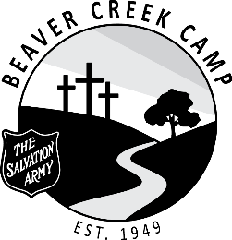

POSITION: Cleaning Staff

DURATION: July 2 – August 26, 2022 (8 Weeks and 2 Days)

OBJECTIVE: To assist the hospitality coordinator with camp cleanliness and laundry duties

SUPERVISION: Hospitality Coordinator / Divisional Youth Secretaries

RESPONSIBILITIES:

- Ensure any lice laundry is handled and laundered appropriately.
- Maintain cleanliness of laundry room and hospital guestrooms.
- Assist in cleaning cabin washrooms.
- Regular pick up and incineration of trash.
- Clean toilets.
- Restock supplies.
- Participate in camp clean up at the end of each camp.
- Attend all staff devotions.
- Ensure living accommodations is kept clean and tidy.
- Be flexible and have a good disposition.
- Work within the total camp program and cooperate with other staff members.
- Be loyal to the aims, policies and regulations of the camp.
- Maintain a responsible level of maturity and leadership.
- Be familiar with Summer Staff Handbook, and all procedures and resources.
- It is understood that the administration reserves the right to dismiss any member of the staff if the best interest of the camp demands it.
- Perform any task beyond those assigned as required.

DECLARATION: As a staff member of The Salvation Army Beaver Creek Camp, I will work to support the mission. I will conduct myself in an honorable manner at all times, according to the standards of The Salvation Army.
Staff Member |  | Date Signed
Witness |  | Date Signed
Divisional Youth Secretary |  | Date Signed

